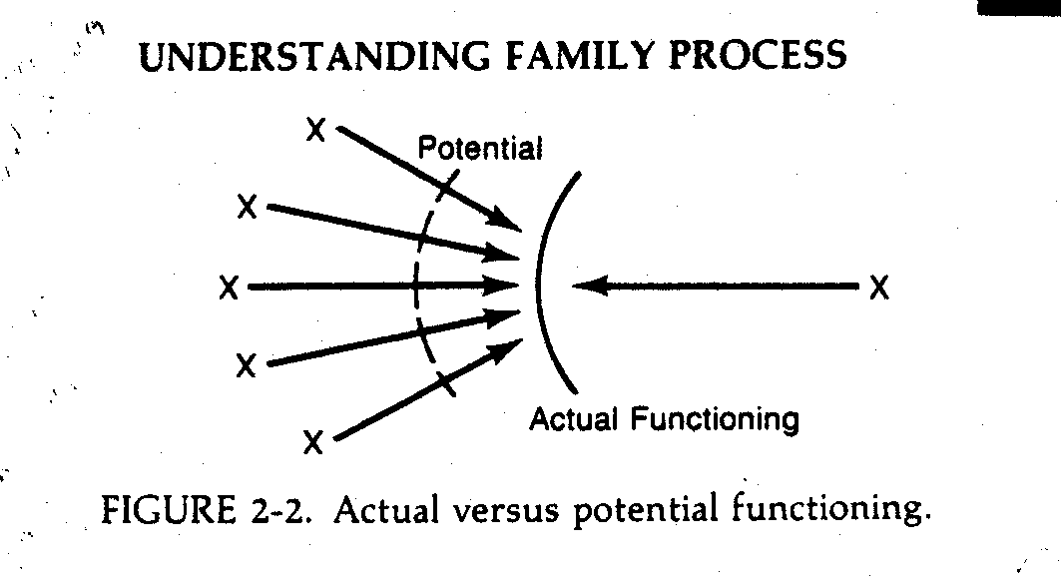

Teresa gave a description of a systems theory concept prior to Pastor Tim’s message this morning (Sunday, September 6, 2020); however, the description was not recorded. Since the concept might be helpful to fully understand the pastor’s message, here is a brief explanation of this systems theory process.

The “X” on the right side of the diagram above represents someone with an issue—something in his or her life is causing great distress. Each “X” on the left side of the diagram represents potential responders to the pain of the troubled person. To the extent the anxiety of those potential responders (family members, friends, or helpful professionals, who are represented by each “X” on the left side of the diagram) causes them to rush in and be “supportive,” the tendency for them to over-function will preempt the potential functioning of the distressed one and fix their “Actual Functioning as their “Potential Functioning.”

As a professional helper, I have learned through training and experience that I have about a seventy-five percent chance (or higher) of helping a client reduce their level of anxiety in a session. But should I? Perhaps there is a higher learning, a transcendent meaning that the Lord means to give at this time in the person’s life? If I interrupt the “Holy Interrupter” and rush in too quickly to relieve the suffering, it is quite possible I will prevent them from a divinely intended, and necessary, experience of the soul.

The “holding back” of providing relief, especially if the helper is capable of providing it, can be experienced very negatively by the distressed person, who may have even become accustomed to having his or her distress regularly relieved in this way.

